**EE468/EE568/CS560 Database Systems | Spring 2022**

**Project: Database-Backend Web Application**

**User Manual**

Designed By

**Rahul Vijaykumar**

**Satya Sai Deepak Velagapudi**

[Yu Liu](mailto:liuy5@clarkson.edu)

**Supervised By**

**Professor Daqing Hou**

**Clarkson University**

**Contents**

**1. Introduction.**

**2. Manual for the Admin.**

**3. Manual for the Professors**

**4. Manual for the Students**

**1. Introduction**

**a. University Course Management System**

We present a prototype of the university course management system to fulfillment

the semester project requirement of ‘EE468/EE568/CS560: Database Systems’.

This is the first version. The system has three modules: Admin, Professors and

Students.

**b. System/tools requirements**

MySQL 8.0.28

Django Version 4.2.11

Python 3.10.4

IDE: Visual Studio Code

**c. Accessing the University Course Management System**

The University Course Management System can be accessed using a web

browser using the address: 127.0.0.1:8000. This is the address of the index page.

The application is not browser specific.

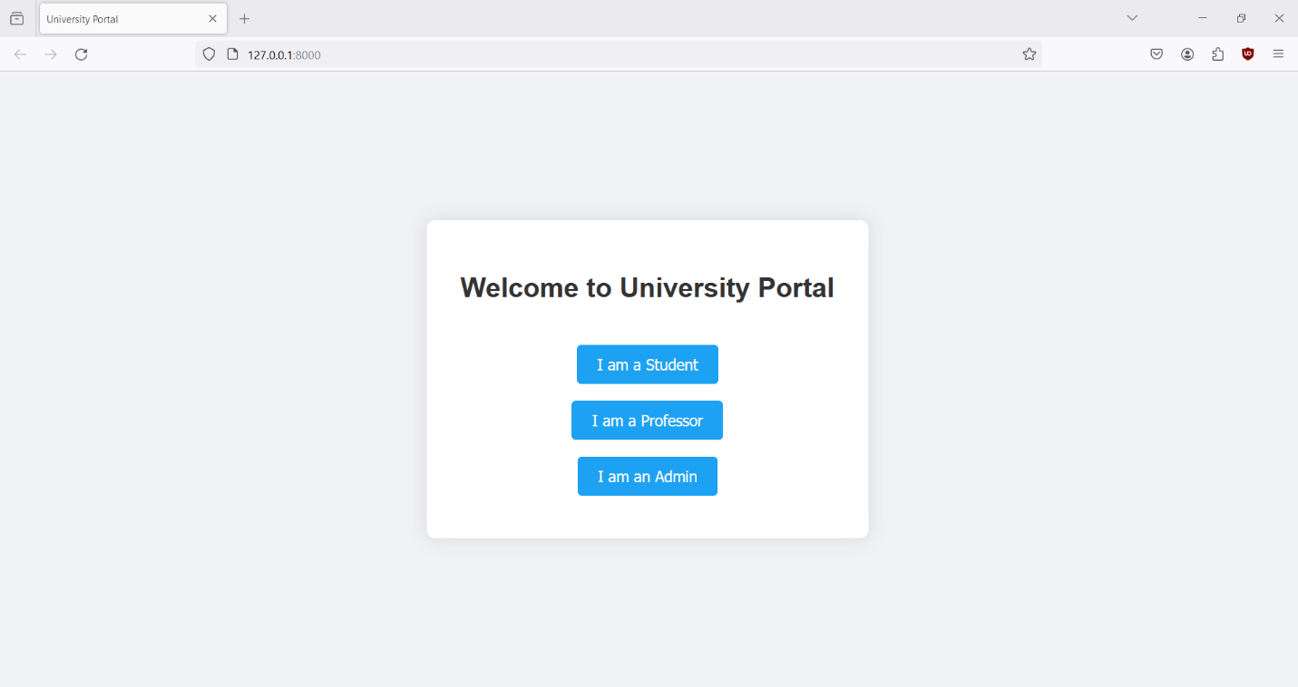

**d. Using the University Course Management System.**

From the Index page, login to authorized users as Admin, Professor or Student.

**e. Authorized User Profile**

The system has three types of profiles:

1. **Admin can perform following tasks**
   1. Create a list of professors sorted by one of the following criteria that can be chosen by the admin: (1) name (2) dept, or (3) salary.
   2. Create a table of min/max/average salaries by department.
   3. Create a table of professor name, dept, and total number of students each professor taught for a given semester.
2. **Professor can perform following tasks**
   1. Create the list of course sections, and the number of students enrolled in each section,that the professor taught for a given semester.
   2. Create the list of students enrolled in a course section taught by the professor, in a given semester.
3. **Students can perform following tasks**
   1. Query the list of course sections offered by dept in a given semester and year.

**Instructions for Admin**

Below shows the functionality of each of the Admin sections with a sample output. Each of the

functions are labeled F1, F2, F3 for the Administrator.

**F1 Query:**

Create a list of professors sorted by one of the following criteria that can be chosen by the

admin: (1) name (2) dept, or (3) salary.

**F1 Name Result:**

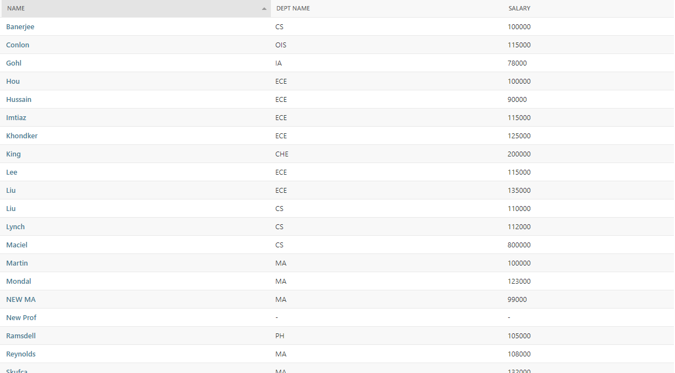

**F1 Department Result:**

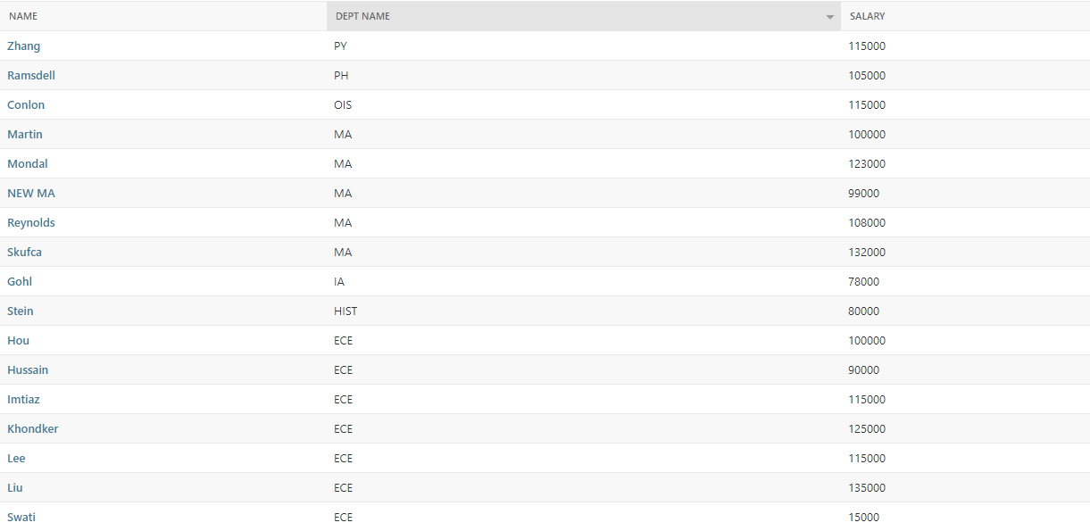

**F1 Salary Result:**

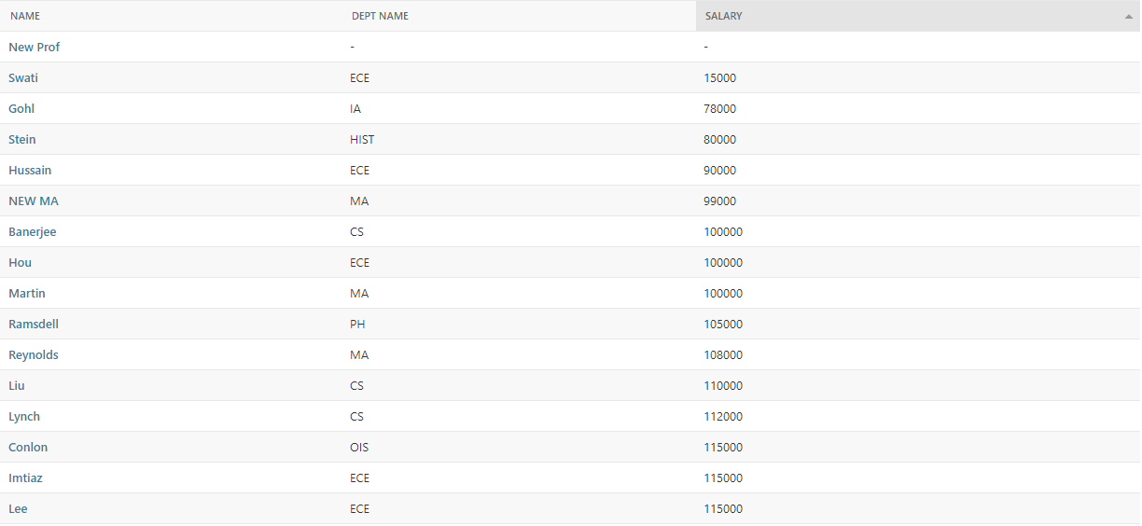

Each of the headers can be sorted in ascending and descending order and also the admin has the option to search for a particular department on top also there is a list of all the departments displayed in the right table.

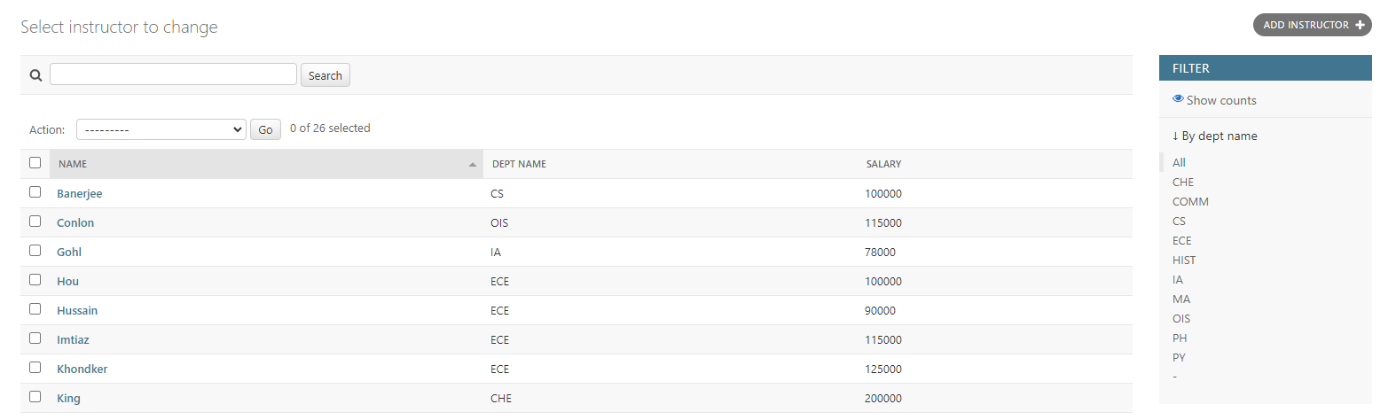

**F2 Query:**

Create a table of min/max/average salaries by dept

The salary tab displayed the list of all min max and average salary of all the departments but the admin can select a particular department from the department list displayed in the right or search for a particular department in the search bar placed on top of a table to get the list of salary details as per the department.

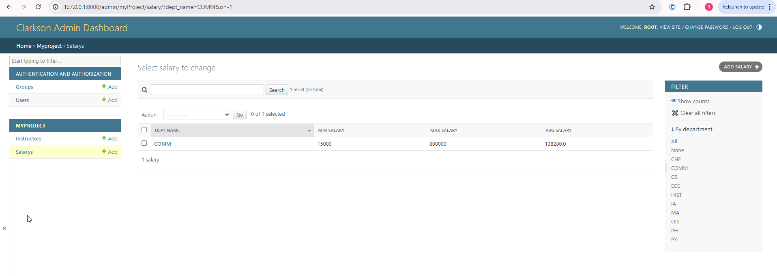

**F3 Query:**

Create a table of professor name, dept, and total number of students each professor taught for a given semester.

Instructions for Students

1. Click on the "I am a student" button on the home page.
2. You will be redirected to the Student Login page.
3. The Student Login page features two fields: Student ID and Password, along with a Submit button.  
   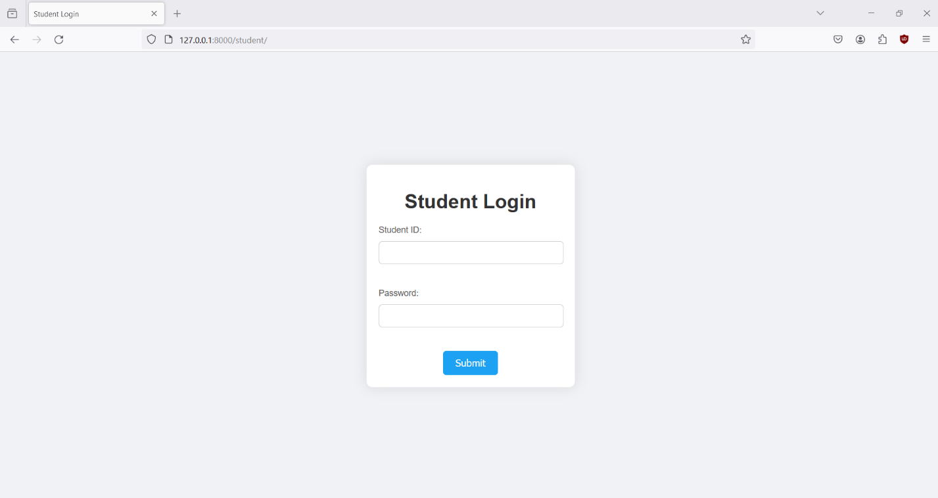
4. Enter your Student ID and Password into the respective fields and click Submit.

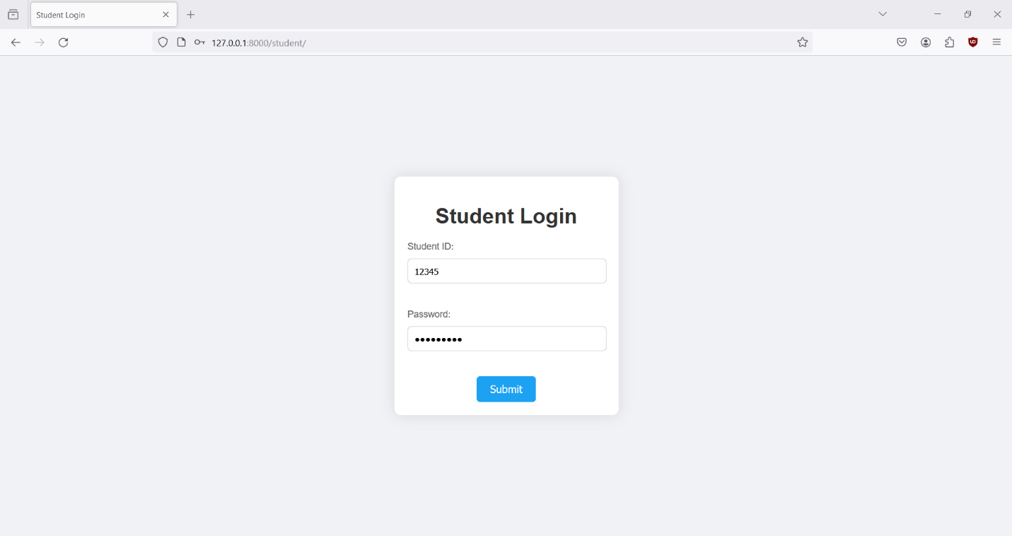

1. If the details provided are incorrect, a message which indicates that the details are invalid, will be displayed on the same page.  
   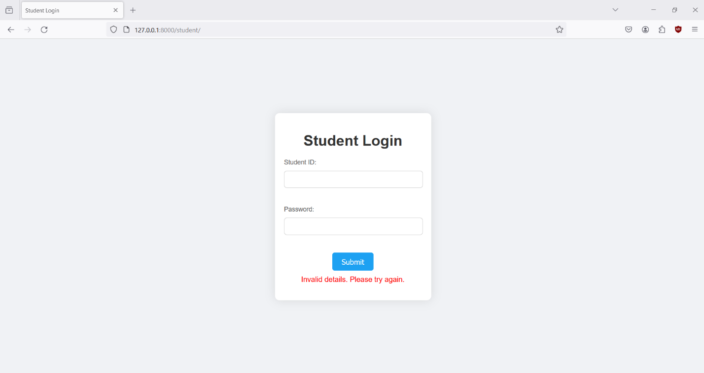
2. If the details are correct, you will be redirected to the Course Section Query form.  
   The Course Section Query form includes three fields: Department, Year, and Semester, along with a Submit button.  
   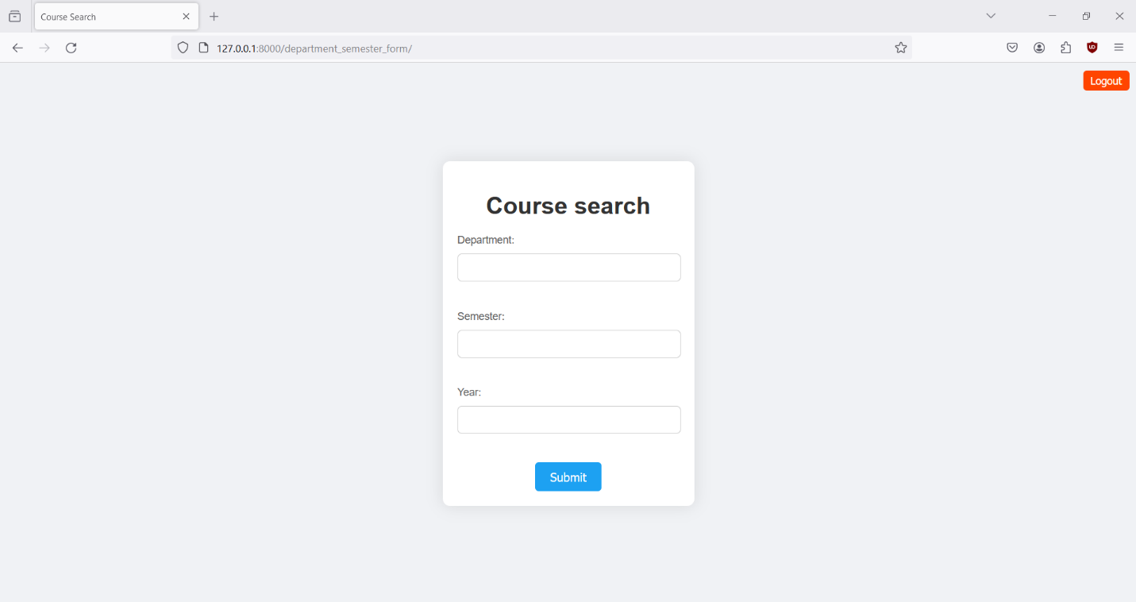
3. Logout button will be displayed on the top right corner of this page(Course Section Query Form Page); click it if you want to logout.
4. Fill in the required information for the Department, Year, and Semester fields and click Submit.  
   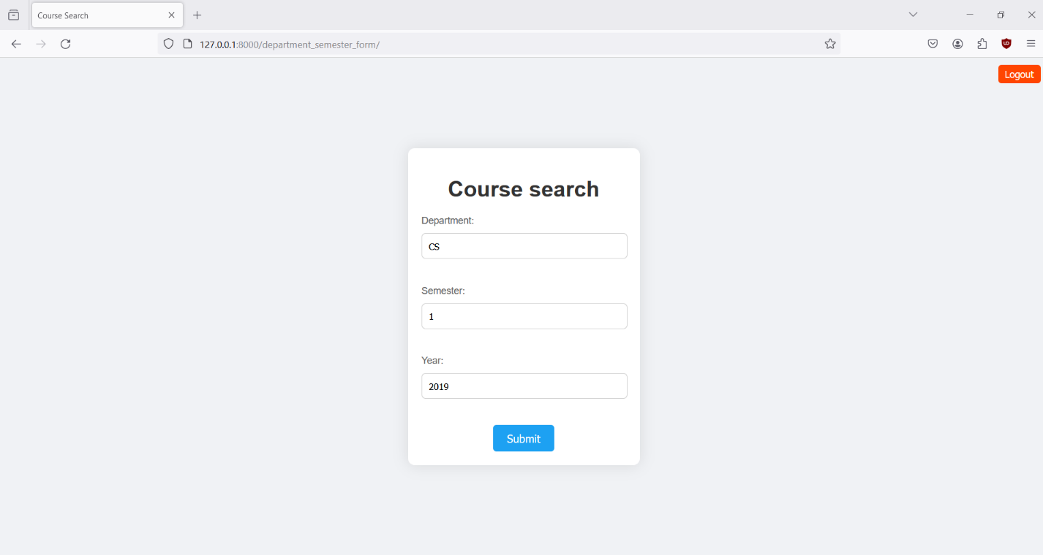
5. After clicking Submit, you will be redirected to another page displaying the course sections offered. If you entered incorrect information, the page will be empty.  
   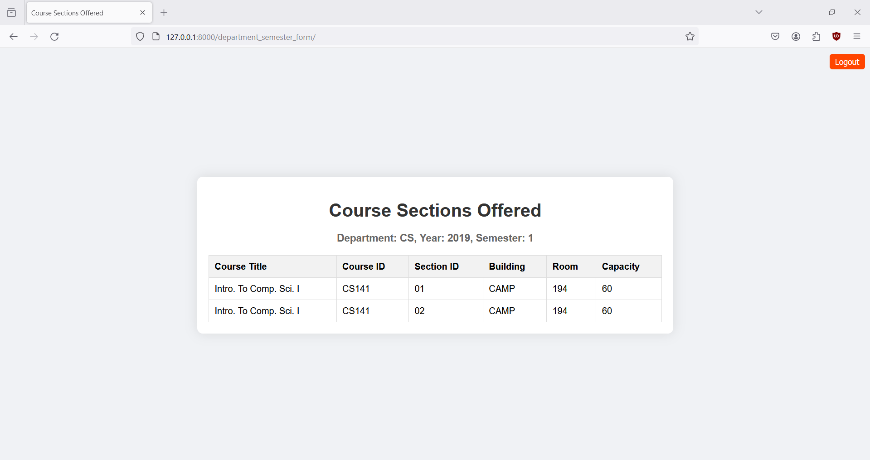
6. Logout button will be displayed on the top right corner of this page(Course Section Query results page); click it if you want to logout.
7. If you hit logout you will be redirected to Home page.

Instructions for Professors

1. Click on the "I am a professor" button on the home page.
2. You will be redirected to the Professor Login page.
3. The Professor Login page features two fields: Professor ID and Password, along with a Submit button.  
   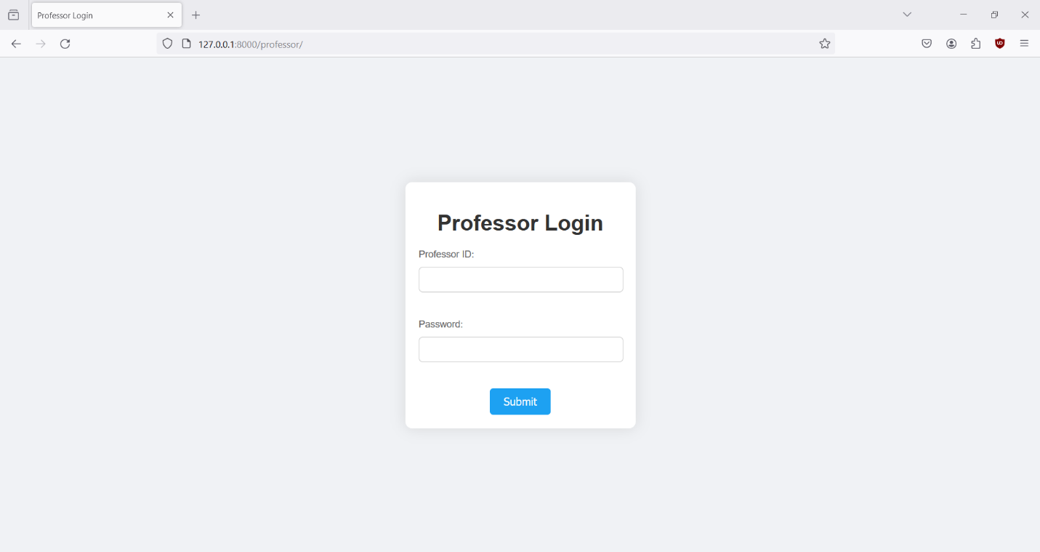
4. Enter your Professor ID and Password into the respective fields and click Submit.  
   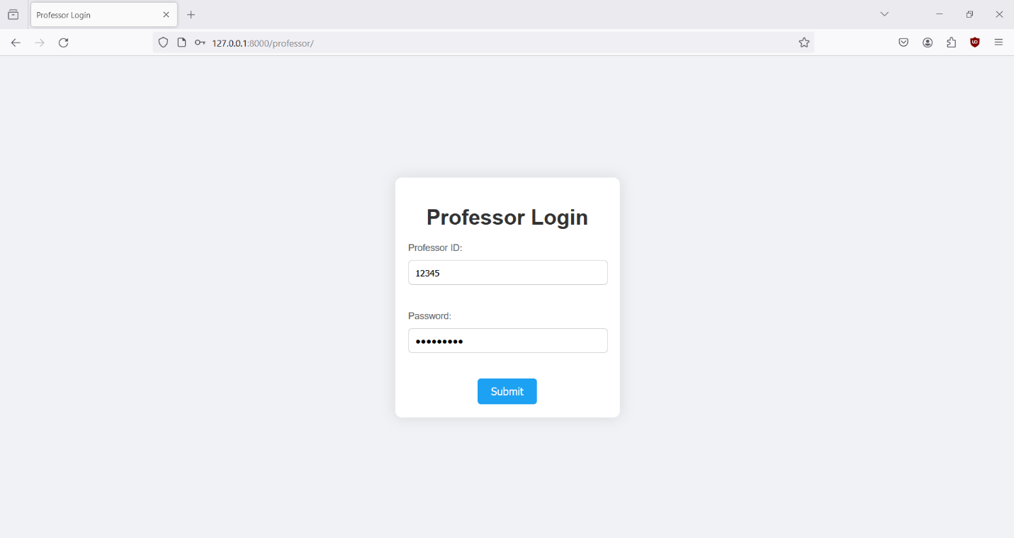
5. If the details provided are incorrect, a message indicating that the details are invalid will be displayed on the same page.  
   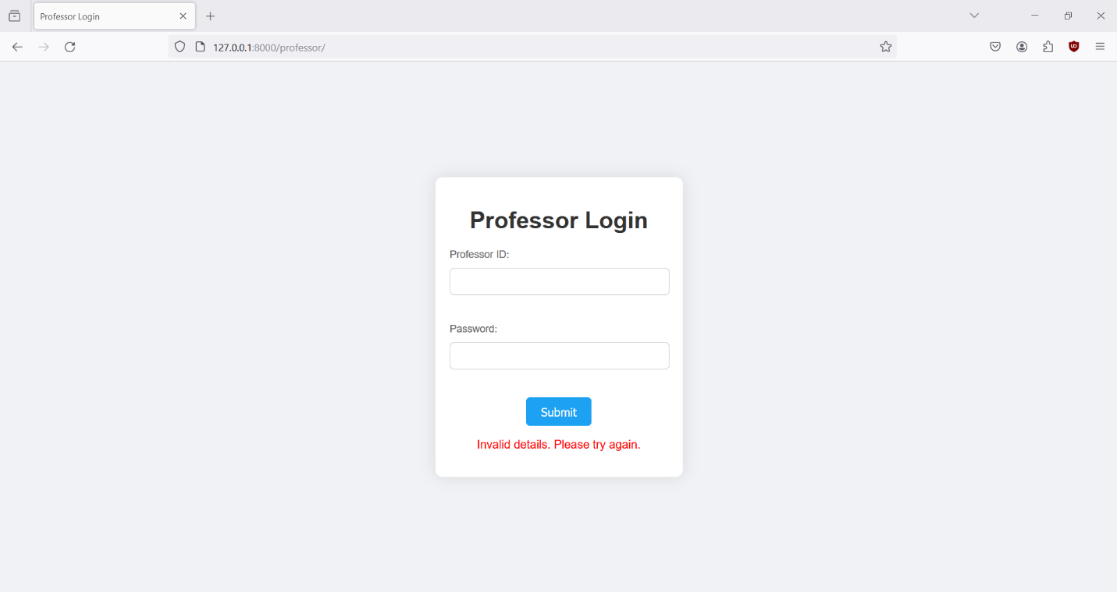
6. If the details are correct, you will be redirected to the Professor Form page. The Professor Form page includes two sections: Course Sections and Students Enrolled.  
   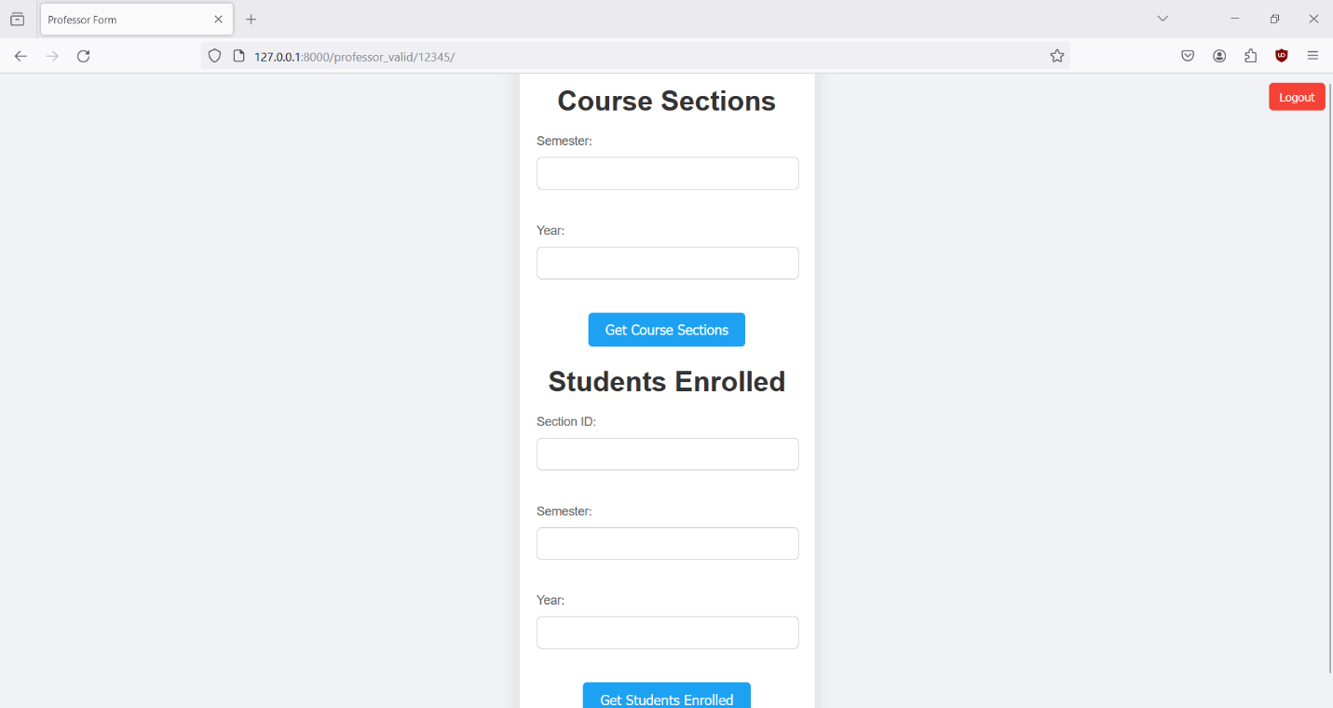
7. A Logout button will be displayed on the top right corner of the Course Section Query Form page; click it if you want to logout.
8. To view the list of course sections and the number of students enrolled in each section that you taught in a chosen semester:

Enter the semester and year into the respective fields.  
Click "Get Course Sections" to retrieve the information.

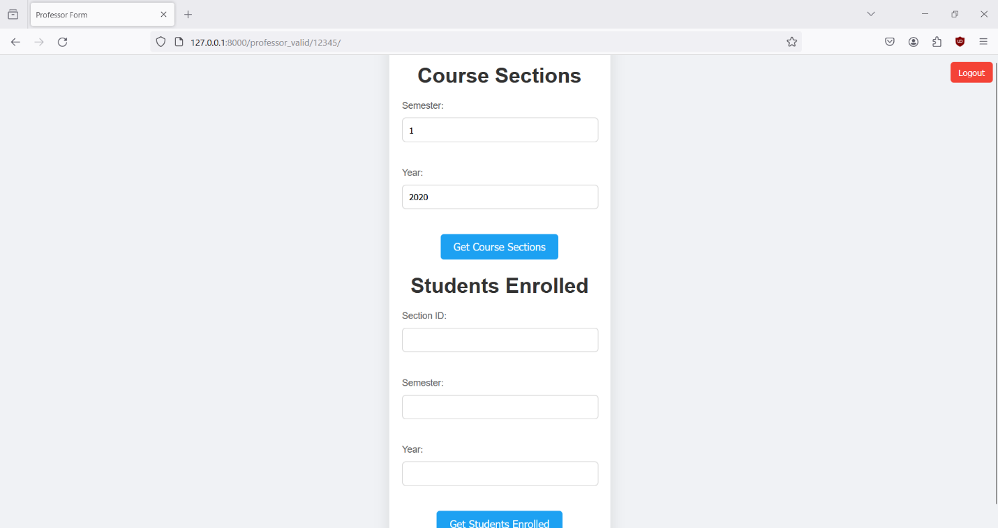

1. After clicking Submit, you will be redirected to another page displaying the course sections offered. If you entered incorrect information, the page will be empty.  
   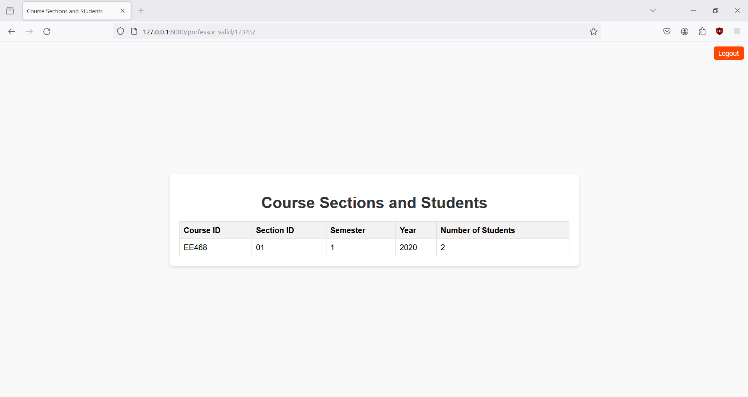

1. To view the list of students enrolled in a specific course section and semester that you taught:

Enter the section ID, semester, and year into the respective fields.  
Click "Get Students Enrolled" to retrieve the information.

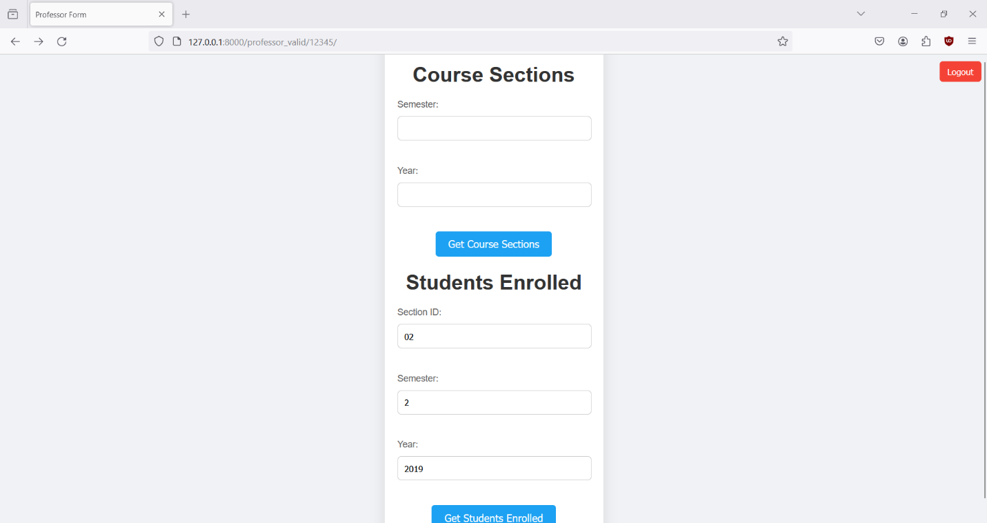

1. After clicking Submit, you will be redirected to another page displaying the students enrolled. If you entered incorrect information, the page will be empty.

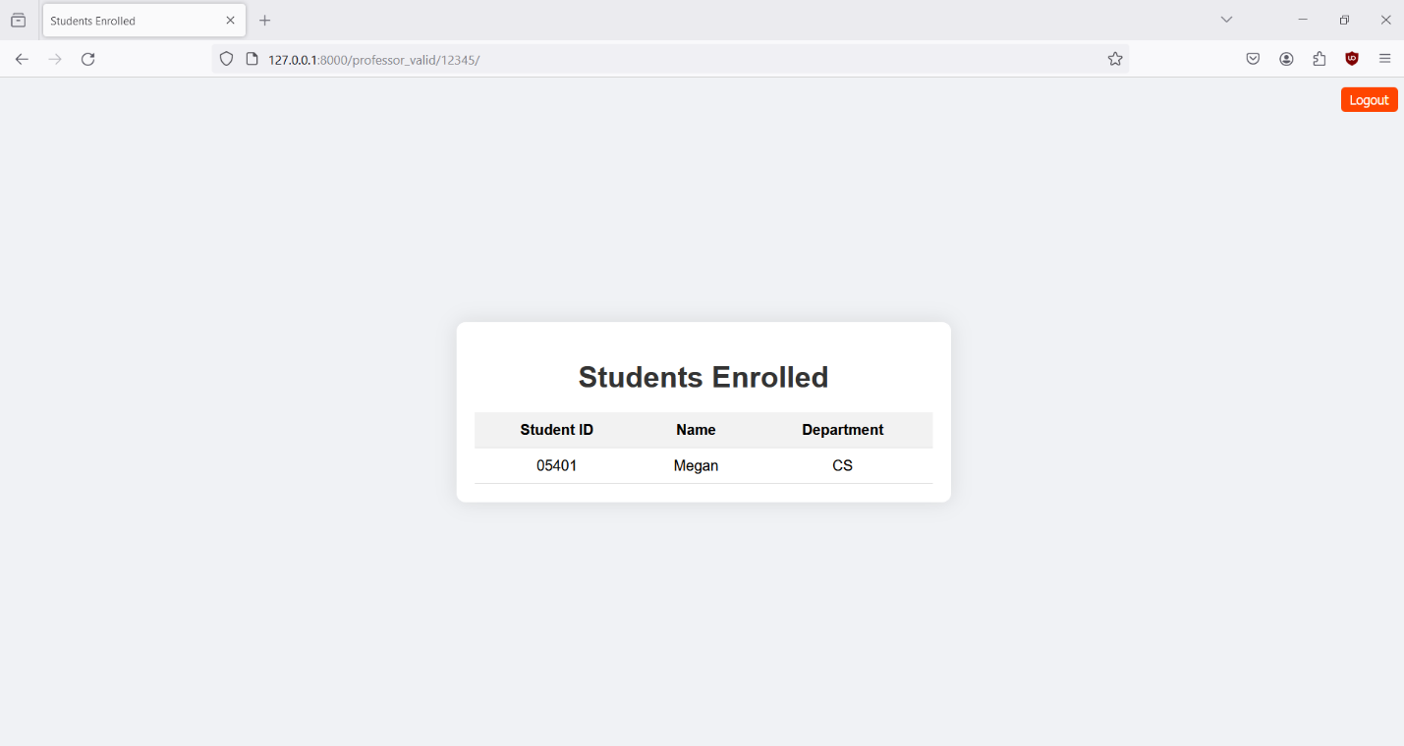

1. A Logout button will be displayed on the top right corner of the Course Section Query results page; click it if you want to logout.
2. If you hit logout you will be redirected to Home page.